Please note:
Form for the Polish institutions
looking for partners in the
Interreg Baltic Sea Region programme
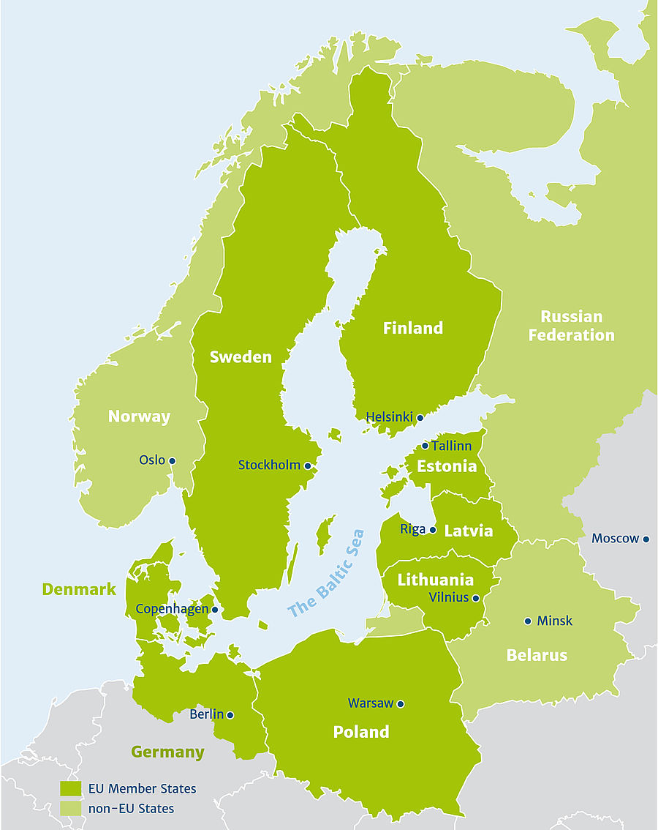
The programme cooperation area covers:
Denmark, Estonia, Finland, Latvia, Lithuania, Poland, Sweden, Germany*, Belarus, Norway, Russia**
* only the States (Länder) of Berlin, Brandenburg, Bremen, Hamburg, Mecklenburg-Vorpommern, Schleswig-Holstein and Niedersachsen (only NUTS II area Lüneburg region)
**only St. Petersburg, Arkhangelsk Oblast, Vologda Oblast, Kaliningrad Oblast, Republic of Karelia, Komi Republic, Leningrad Oblast, Murmansk Oblast, Nenetsky Autonomous Okrug, Novgorod Oblast and Pskov Oblast
- The Form is for Polish institutions only – it is a country specific tool prepared by the Polish National Contact Point of Interreg Baltic Sea Region (Ministry of Economic Development).

- Partner search tool prepared by the Joint Secretariat - LinkedIn group “Partner search - Interreg Baltic Sea Region Programme” – is available for institutions from all programme countries. More details on: www.interreg-baltic.eu.

- Binding documents for the 3rd call are prepared in English and are available on the programme website:
www.interreg-baltic.eu. The National Contact Point provides additional support: documents in Polish (for reference only) on www.ewt.gov.pl (Przeczytaj o programach).

- Prior to filling in the Form, please get acquainted with the 3rd call application documents. If you have questions please turn to the National Contact Point: Ministry of Economic Development, Territorial Cooperation Department, Transnational and Interregional Cooperation Unit, contact person: Monika Strojecka-Gevorgyan, Ph.D. (email: Monika.Strojecka-Gevorgyan@mr.gov.pl, tel. 32 253 90 08).

- Send the filled-in Form by e-mail to the following national Contact Point address: anna.stol@mr.gov.pl

- By sending the Form, you agree to sharing your personal data with cooperating institutions from countries covered by Interreg Baltic Sea Region. The Polish Ministry of Economic Development does not process the data and bears no responsibility for the use of the information passed to other programme’s bodies.

Important notice
The topic of interest must be in line with the programme priorities and specific objectives, otherwise the Form is not valid. The National Contact Point will distribute only the forms that have been properly filled-in.

The Polish institution looking for partners:
Full name* | Type** | Region
* Please provide Polish and English name
**For example: national, regional or local authority, university, regional development agency, private company etc.

Planned role in the project:
Options | Please put ‘X’
Lead Partner
Partner

Topic of interest:
Options
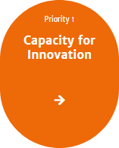 | 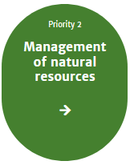 | 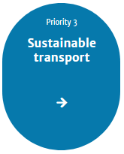
Please put the specific objective number* or ‘X’, if you are not sure as to the exact project topic but you want to indicate a general area of interest

* e.g. 1.2, 3.5 etc. You may indicate more than one 1 priority and/or specific objectives.
**Detailed information on the priorities and their specific objectives at: https://www.interreg-baltic.eu/thirdcallforapplications.html

More information for potential project partners (mandatory fields)
Expand on the topic of your interest* | Describe your competence and experience in the chosen topic** | Provide more information on your planned activities and involvement within in the project*** | Other information
* For instance, what is the need you want to address, what is crucial for your institution/city/region, what would you like to achieve thanks to the cooperation, what should be changed in the chosen topic, who may benefit from the project (target groups), etc.
** For example, involvement in similar projects, cooperation with foreign institutions, tasks of the institution in line with the project topic, good cooperation and/or links with public authorities/institutions in the chosen topic, achievements, good practices in the thematic area etc.
*** For example, planned: pilot actions, activities, results, involvement of stakeholders, need of using budget line no 7 ‘Expenditure for specific project activities’ (e.g. expenditure for large research activities at sea etc.) etc.

Desirable project partners:
Options | Please fill-in
Country:
Region:
Institution experienced in the field of*:
Specific type of institution**:
We have no preferences as to the project partner/lead partner country.
* The field must be in line with the programme priorities and specific objectives.
**For example, national/regional/local authorities, universities, development agencies, institutes, foundations, R&D etc.

Institutions interested in cooperation are requested to contact:

Mr/Ms:
Email:
Phone:
Mobile:

